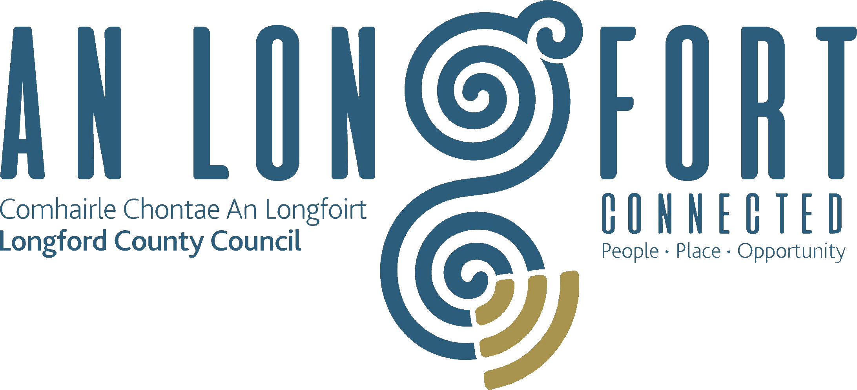

BALLYMAHON MUNICIPAL DISTRICT

Minutes of Meeting of Ballymahon Municipal District held in the Council Chamber, Aras on Chontae, Longford on Friday, 15th February 2019 at 11.00 a.m.

CATHAOIRLEACH: Councillor Paul Ross

MEMBERS PRESENT: Councillors – Mark Casey, Colm Murray,
and Pat O’Toole.

IN ATTENDANCE: Mr. Terry Rooney, Senior Executive Officer.
Ms. Linda Higgins, Administrative Officer
Mr. Paul Newell, Senior Executive Engineer.

APOLOGIES: Ms. Barbara Heslin, Director of Services.
Councillors Mick Cahill and Gerard Farrell.

MEETINGS
ADMINISTRATOR: Ms. Anne. Lee.

PART 8 REPORT

Mr. T. Rooney, Senior Executive Officer, informed the members that the proposed development forms an integral part of a wider regeneration plan to provide a focal point within the town centre, improving pedestrian accessibility, connectivity and amenity within Edgeworthstown overall.

On the proposal of Councillor Pat O’Toole seconded by Councillor Colm Murray, it was unanimously agreed to adopt Part 8 Report (Planning and Development Act 2000 (as amended) and Planning and Development Regulations 2001) (as amended) in respect of upgrading and alteration of the existing public realm, to include footpaths, tree planting, street furniture and lighting, undergrounding of public wires, tabletop pedestrian crossing, revisions and alterations to car parking, signage and all associated site works, as circulated.

Mostrim Oaks, Edgeworthstown.

Cathaoirleach, Councillor Paul Ross, provided an update regarding the positive actions being taken at Mostrim Oaks, Edgeworthstown.

This concluded the business of the meeting.

Signed: _______________
Anne Lee,
Meetings Administrator.

Confirmed and adopted at Ballymahon Municipal District Meeting held on the
14th March 2019.

Signed: _______________
Cathaoirleach.

